Passivistas: the house project

**Stefan Pallantzas**, civil engineer, certified Passive House designer, PROJECT 15  
112, Anastaseos str., 15669, Papagou, Attiki, Greece, Telephone +30 211 4081109, email pallantzas@gmail.com

**Athanasia (Nasia) Roditi**, architect, certified Passive House designer, ARCHITECT-LAB 18, Chryssanthemon str., 15354, Glyka Nera, Attiki, Greece

Tel.: +30 210 6040993, email : nroditi@yahoo.com

1. Project description

The project “Passivistas: thehouse” is an Energy Upgrade and retrofit of a typical 142m2 one family house of the 60s in Athens according to the Passivhaus standard. The goal is to minimize the need for conventional heating or air conditioning.

The building is located at the Municipality of Papagou and was built back in 1964 on a 520 sq.m. corner plot, the two facades looking Northeast and Southeast. It consists of 2 units; a 98,80 sq.m. 2 bedroom private residence on the ground floor and a separate semi-basement 43,60 sq.m. storage/boiler room; the last one will be converted into an office.

The building’s TFA is 115,30 sq.m. and for the existing building the following figures were calculated in the PHPP:

Heating demand = 301 Kwh/m2a

Heat load = 129 W/m2

Cooling demand = 301 Kwh/m2a

Cooling load = 129 W/m2

Estimated airtightness n50=5,00 1/h

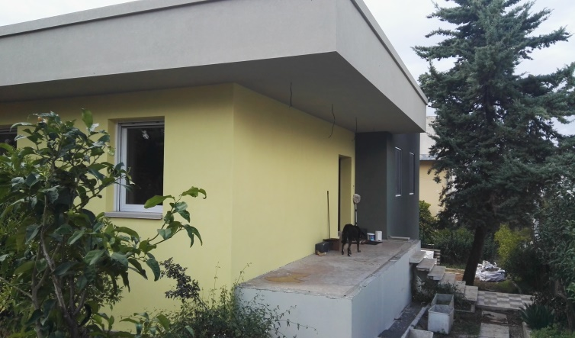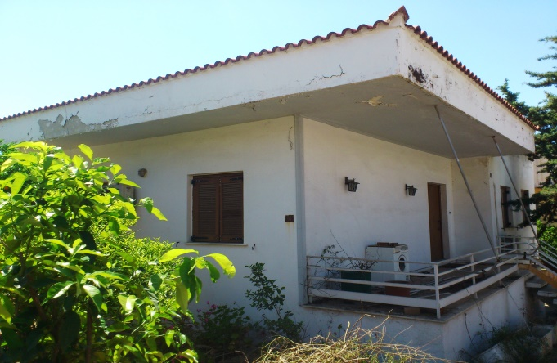

**Figure 1: Before retrofit** **Figure 2: After retrofit**

1. Construction
   1. **Building envelope & Thermal Bridges**

The existing building is of massive construction (reinforced concrete slabs and perforated brick walls) and was completely uninsulated, with major thermal bridges all around its perimeter due to balconies and projecting structural elements. It had wooden frame windows with single glazing.

For the retrofitted building the following figures were calculated in the PHPP:



**Figure 3: PHPP results**

All existing thermal bridges were resolved to have a minimum impact on the heating and cooling demand; their new Psi values are calculated accordingly.

The enerPHit consists of:

Roof, external insulation = 30 cm of EPS [λ=0,030 W/(mK)]

Ext. walls, external insulation = 15 cm of EPS [λ=0,030 W/(mK)]

Floor slabs, internal insulation = 5 cm of EPS [λ=0,030 W/(mK)]

New windows & front doors, Uf=0,78-1,00 W/(m²K) Ug=0,50 W/(m²K), g=0,54. The dimensions of the southern windows in the kitchen and the bathroom were increased and all windows were converted to single opening in order to increase the glazing area.

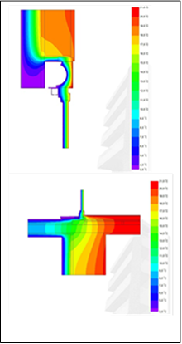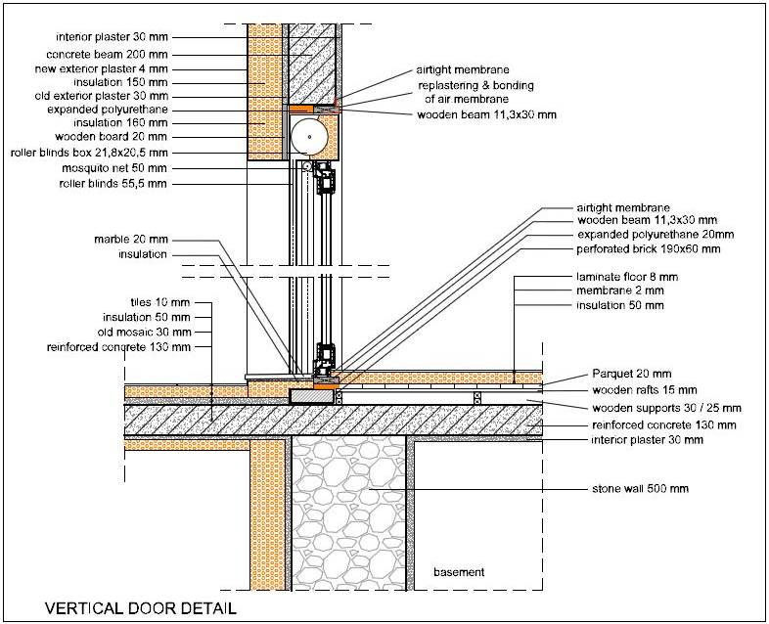

**Figure 4: Patio door with roller blinds Figure 5: Thermal imaging**

* 1. **Summer concept & shading**

All south-east, south-west and north-west windows have automatically controlled roller blinds for temporary shading in summer. All windows –but one in the kitchen- can be opened or tilted for natural night cross-ventilation in summer and have mosquito nets on the outside. On the south-west and north-west side of the building –in the area of the 2 balconies- horizontal tents will be placed in order to shade the windows and the balcony’s sitting area during midday and afternoon hours in summer.

Night ventilation with tilted windows to the north and southeast is used for passive cooling. The ground heat exchanger decreases the incoming air temperature down to 25-27 degrees. A 2,5 Kw inverter split unit , installed in the living room, covers actively the cooling demand.

* 1. 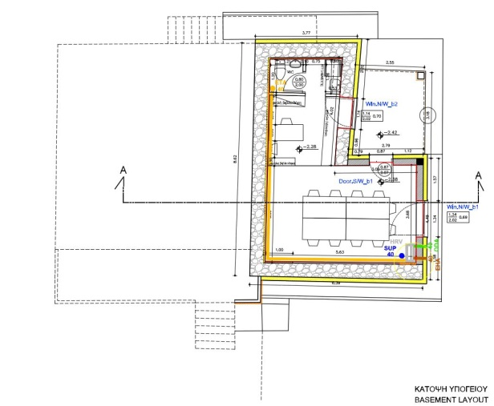**Ventilation & heating concept**

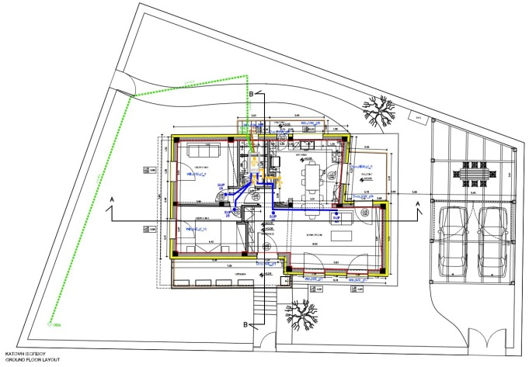

**Figure 6: Ventilation system residence Figure 7: Ventilation system office**

The existing building was heated with oil and radiators and a traditional fireplace and had two 2,5KW split units for cooling. All these were demolished. The dimensions of the southern windows in the kitchen and the bathroom were increased and all windows were converted to single opening in order to increase the glazing area.

New HRV systems were installed one for each unit (house and office). For the residence the normal air-flow is 110m3/h. For the office we have chosen a bigger unit with 250m3/h capacity to cover the presence of nearly 10 people, e.g. during courses.

Both units have a 1KW supply air heater, which will cover the needs. The split unit will serve as backup, installed mainly for cooling. The residence unit is also coupled with a 30m long, 1,50m deep, ground heat exchanger.

1. Blower door test & Monitoring

**Figure 8: Blower door test results - residence.**

The blower door test was made after finishing the internal airtightness layer (plastering) and was unexpectedly perfect! Two separated test were made, one for the residence with 0,48 1/h result and one for the office with 0,85 1/h result. We expect to have better values in the office, which was not fully ready during the test. So the average value for the building was 0,56 1/h at n50.

1. Lessons learned

The experience with the 9th version of the PHPP, although it was still only in german version, was great. We have used the variants to create several alternative scenarios for the envelop. The new user friendly interface helped us to increase the productivity and make fewer mistakes. Especially the new windows section gave us the advantage to check every single window and to optimize their gains and losses.

Our calculations showed that we could reach the target of 15Kwh/m2a with nearly less than 10cm of external insulation and double glazed windows. But we decided to go further and increase the thickness in order to achieve the 10W/m2 and eliminate the need of conventional heating. This was achieved with 20cm of insulation and double glazed windows with a high g-value. Then we found out that there was no option in the greek market to find a g-value over 0.54. So we decided, in order to keep the positive balance of the windows, to go to triple glazing with a Ug-value =0,5 W/m2K and a g-value of 0.54. This reduced the wall insulation thickness to 15cm.

Too many thermal bridges in total had to be considered. Due to balconies and projecting structural elements, 18 different structural thermal bridges were identified; 2 of them were solved using insulation methods and the rest were calculated and taken into account in the PHPP. Also, due to 3 different types of windows used, combined in 2 different installation strategies, 16 different window installation thermal bridges had to be calculated.

A lot of tradespersons training had to take place on site, as very few were familiar with the Passive House concept. This slowed down the construction process a bit, plus some repair work regarding the airtight envelope had to be made.

We were excited with the blower test result. Although it was an old house and we were afraid of not achieving easily the specification, the result was extra ordinary. We believe that this happened because of the good internal plastering of the house, which is a big advantage of the way we build in Greece. Furthermore we saw that, if you know where to care about airtightness, then the result is always good.

In Greece there is no knowledge about planning and installing a ventilation system. The whole procedure was developed and implemented by the team of engineers – passive house designers. After planning the duct system and calculating the airflows and the pressure drops, we installed the unit and the ducts, we installed the preheater, we made the system tight and reduced the noise, we measured the flows and calibrated the system. A lot of things have to be done on this sector; the suppliers have to educate their stuff for installing ventilation units.

1. Social Impact

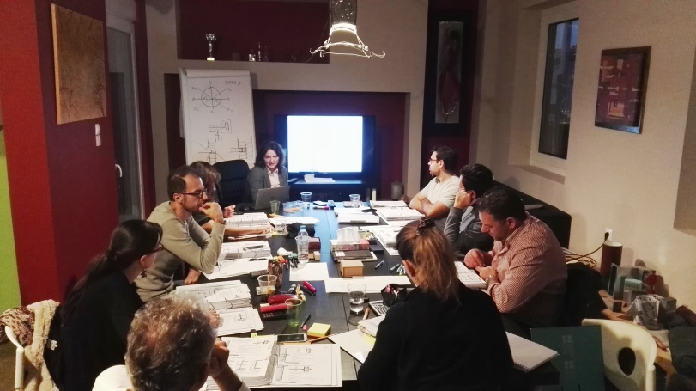

Figure 9: CEPH course at passivistas

This project is a critical point on the road to the greek NZEB building of the 2020. We want to show to the people, to the engineers, to the market, to the government that consuming much less energy is achievable and cost effective. And after that, it's easy, using renewables sources, to achieve a house which has a positive energy balance that means a real sustainable house.

The way of design and step-by-step implementation, and the subsequent monitoring and metering project will promote collaborative processes among executives of HPHI, certified passive building designers, engineers and technicians from all sectors and commercial and technical department of companies manufacturing and marketing passive house components. It will offer to every citizen through open public data all the information required on how to drastically save energy in his house, while improving quality of life and contributing substantially to the fight against global warming.

After completion of the project the house acts as media and collaborative process hub aimed to prove in practice the ability to upgrade the energy consumption of residential buildings in Greece and the Mediterranean area , so they do not need conventional heating or air conditioning, while drastically reducing energy costs and improve the quality of life in them. And all this at an acceptable cost to the community. Specifically the project will implement the following action axes:

. The ground floor of the project will act as an open residence for seven consecutive years, open for guided visits, lectures and presentations to the public and to engineers, etc

· The space of the basement will serve as headquarters of HPHI as well as a venue of seminars, training, materials showroom etc.

· HPHI created the project website and will cover via an interactive blog all steps and aspects of the project. On the website every citizen can be informed on how to design, stages of implementation, the specifications of materials and controls, and to see online measurements and actual operation and consumption of the building. On the other hand, all companies participated in the project will have access to all data available, concerning the behavior of the building, of all materials and equipment and will cooperate with HPHI and the project management in order to improve quality of their products.

The team developed media material available to everyone, videos, posters, pamphlets, a technical handbook etc. The building will be the first to be certified as a EnerPHit Plus in the Mediterranean Area, which means it will be the first Building in the region, producing more energy than consuming. It is expected to consume about 3.000 Kwh annually, while with the PV system producing more than 7.000 Kwh. For now this amount of energy will be sold to public energy company via net metering, but in the future we are thinking of making the building totally autonomous.

1. References

[References]

[www.passivistas.com](http://www.passivistas.com)

<https://www.facebook.com/passivistas/>

<https://twitter.com/passivistas>

**Summary**

Passivistas:TheHouse is a critical point on the road to the Greek NZEB. We, all engineers and passive house designers, members of the Hellenic PH Institute, want to show to the people, to the engineers, to the market, to the government that consuming much less energy is achievable and cost effective.