WP6 – European on-line communities Germany (DGNB, PE INTERNATIONAL AG): GREEN VALUE - Cost inclusion to life cycle based assessment of buildings
Launch strategic European on-line communities in collaboration with BUILD UP

Description of work:

a) Overview of the Work package:
This Work Package ensures a trans-European focus of C21-EGBE, through the moderation of 6 thematic/benchmark communities that ensure that C21-EGBE contributes to aligning the market behaviours of the European construction industry to the regulatory and performance goals set by the European Commission, especially those related to eco-design. Furthermore, it will also provide detailed industry feedback on the adequacy and pertinence of these goals and standards.

A C21 co-beneficiary/partner moderator will provide leadership for each community, and each beneficiary partner will facilitate linked local networks. These strategic trans-European communities and local networks will provide a unique window on emerging Europe-wide markets – standards, suppliers and tenders. This information will particularly help smaller SMEs and expert professionals expend into broader European markets. This is necessary to provide market opportunities for all market actors, but it is of particular importance to SMEs. Indeed smaller companies suffer from information asymmetry as compared to multinational suppliers.

Through dynamically linking case study information and comparative rating with these trans-European themes, the goal of this Work Package is to provide practical facilitation of Europe-wide competition for energy efficiency and sustainability performance in rehab and new construction. Opening this competition to a Trans-European scale of is essential. It can reduce costs for buyers, as it rapidly builds critical mass in market demand for innovative energy-efficient offers in sustainable construction, while it ensures competitive, skilled responses to these offers.

Specific subjects that fulfil the conditions given in WP4 could also be developed in a new Community at European level.

The workload of moderator is considered to be low:

- If moderator of a thematic community, he only has the workflow of the community which is a rather low one, and on an important subject.
- There is a content manager for articles
- There is case study reviewers

The final load for individuals is rather low. They are all based on administration rights and email alarms when a new post is moderated.

b) Description of the tasks:
T.1 Moderate “Price/Performance; real payback on devices; cost effective solutions for a “Zero Energy Building” community.”

T1.1 Moderate a Price/Performance/ real payback on devices (from photovoltaic to boilers, and non energy as water recycling) to promote the cost effective solution in Europe; demonstrate to buy-side players the best value for money, paving the way towards Zero Energy cost effective Buildings.

T1.2 Promote best practice approach and induce case studies on paybacks.

T1.3 Conduct surveys and best practice examples
Outputs of this work package (apart from deliverables):
O6.1 An online “Price/performance; real payback on devices” community with approximately 500 members primarily from the buy-side including a Europe-wide best practice approach and a dynamic benchmark with Periodic “Greenwashing” alerts on misleading claims.

Deliverable of this work package:
D6.1 Bi annual Price/performance; real payback on devices” reports containing “greenwashing’ alerts to C21-EGBE members on the buy-side. (Alerts published on-line also, in all partner languages) and an annual Price/Result benchmark awards (Link to WP5)

Proposal
As the “Price and Performance” Community is going to be installed at the european level of C21 the community has to fulfil the ambiguous task to be of interest in all participating countries. As becoming apparent in the graphic image below the indented community on Price and Performance is connected to a vast number of regulations, standards and (overarching) initiatives on the European level. Without going into further detail, it is surely of great importance to create cost effective ways to implement all the political requests and demands for sustainable buildings, so costs and monetary benefits are the most powerful drivers of economic and social entities to pursue the way towards a zero energy buildings society.

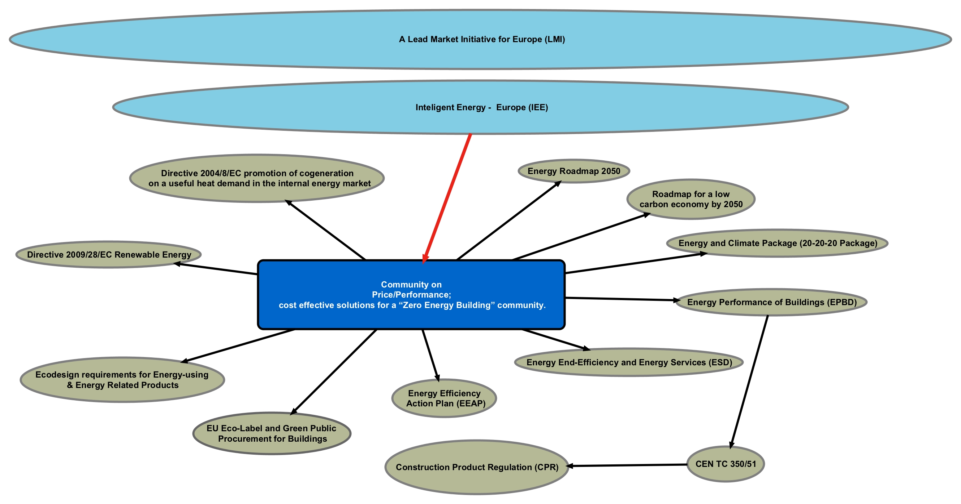

On the national level you find a likewise differentiation in regulations, initiatives and status of development in the field of sustainable constructions depending on the nation observed. With this overcomplexity in mind, the “Price and Performance” community should not enforce a certain “methodology” to fulfil the intended goals explained above (Description of work), but to leave the implementation and realization of content to the interested actors in the participating nations. With that approach the community will be enriched with the needed and relevant content to the different nations, as the discussions and methods applied in the German market are different to the discussions and methods as for instance in Spain.

In order to fulfil this needed degree of freedom and to guarantee expedient content in reference the goal of this WP: “to provide practical facilitation of Europe-wide competition for energy efficiency and sustainability performance in rehab and new construction. Opening this competition to a Trans-European scale of is essential” the community should be pre-structured to meet both requirements. This pre-structure should work as a kind of framework that can be filled with content in accordance to the specific demands of the diverse markets without killing the openness that makes such communities attractive. Such a framework can be achieved by adding a number of guiding sub-categories to the community that are already in discussion on the expert level in Europe. From our experience and discussions we suggest the following title and sub-categories:

- Community Title:
GREEN VALUE - Cost inclusion to life cycle based assessment of buildings

- Subcategories:
- Economic value of partial investments
- Economic value of total investments
- Internalization of external costs/Parallelism of environmental impacts and future costs
- Quantification and value of social aspects
- Conservation and enhancement of building value

These topics would attract the necessary stakeholder groups in all countries. Another advantage would be the chance to establish a competition between the markets. The "more" advanced stakeholder groups might discuss things on another level and go more likely for the topics 3-5. The less advanced will have the chance to follow the discussion and adapt it to their needs or work on and introduce their own solutions, which on the other hand might be of interest to other stakeholders. So an intra- and intermarket exchange can be established that allows interested actors to find solution outside its usual environment and market.

Following that thinking two kinds of "formats" should mainly contribute to the community:

- Description of “Best practice” examples to allow everybody to participate on real world experience. (linked with: C21 Innovation)
- “Discussion papers”, to facilitate the exchange of scientific and political ideas, so the community has the potential to bundle all the loose strings you find on these topics and become "one stop place" for anybody interested (linked with: C21 News)

On both formats an open discussions can follow via the community.

Stakeholder Inclusion
To start the community it is essential to get a sufficient number of participants that produce interesting content so the community has the potential to become self-supporting. The relevant stakeholder groups for that Community are all the ones that are interested in the assessment of buildings, on the demand side as on the supply side. For example:

- architects/planers
- owners/building cooperations
- certifiers
- facility managers
- contractors (big players/SME’s)
- chambers
- associations
- …
To attract them in the first place it is required to show them the added value they can get put of this community and platform, which is:

- Forum of experts (buy side as sell side)
- Additional promotion of their products/work/ideas via social media
- Insights on new markets/trends/solutions
- Competitors are already there (we have to make sure they are or at least show that they are asked)
- Growing number of participants (intended number of participants etc. (see annex) should be shown)
- Free of charge
- Easy to handle (“extra promotion just a few clicks away”)
- Nothing to loose if the platform fails (they are not connected to the administration or management of it; this is an argument that may be should not be written down in order not to imply a negative assumption on the success of C21)

To get the mentioned stakeholders involved the following ways and order of address are recommended:

- Usage of personal contacts, start with the persons, organisations, companies you know
- Contact of chambers and associations, they are interested to offer their members new features and they are good multipliers
- Address of companies and actors of the list above (pick 2-3 first out of each category that you deem most interested, internet research will help to find stakeholders that are dealing with the topics of the community, than work down others)
- Usage of mailing lists

Community short explanation (online):
One of the most discussed and on the same time insufficient examined issue is the ratio of costs and benefits of sustainable buildings. The theme goes that green or sustainable building save resources, create a healthier and more productive environment for their users and generate higher return on investments in the case of rental incomes. Nevertheless planers and owners are confronted with the matter of up-front costs versus life cycle costs and questions about the cost effectiveness of partial investments like photovoltaics or new appliances. Another price and performance issue is the lack of data or methods about how to measure the proclaimed social effects of sustainable buildings.
In general planers are often confronted with either a lack of reliable cost - benefit data or the difficulty to get easy access to such data. This community shall help to overcome both problems. To achieve this goal, the community is split into different sub-communities to facilitate clarity and feedback on documents, proposed methods or ideas. Feel free to change this community structure to the practitioners needs.

Community pages:

